**Exception Handling**

The **exception handling in java** is one of the powerful *mechanism to handle the runtime errors* so that normal flow of the application can be maintained.

What is exception?

**Dictionary Meaning:** Exception is an abnormal condition.

**In java:** exception is an event that disrupts the normal flow of the program. It is an object which is thrown at runtime.

What is exception handling?

Exception Handling is a mechanism to handle runtime errors such as ClassNotFound, IO, SQL, Remote etc.

**Advantage of Exception Handling**

**To maintain the normal flow of the application**.

Exception normally disrupts the normal flow of the application that is why we use exception handling. Let's take a scenario:

1. statement 1;
2. statement 2;
3. statement 3;
4. statement 4;
5. statement 5;//exception occurs
6. statement 6;
7. statement 7;
8. statement 8;
9. statement 9;
10. statement 10;

Above 10 statements in your program and there occurs an exception at statement 5, rest of the code will not be executed i.e. statement 6 to 10 will not run. If we perform exception handling, rest of the statement will be executed. That is why we use exception handling in java.

Hierarchy of Java Exception classes

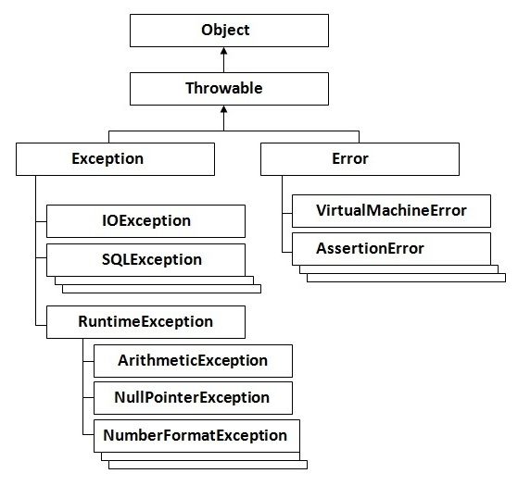

Types of Exception

There are mainly two types of exceptions: checked and unchecked where error is considered as unchecked exception. The sun Microsystems says there are three types of exceptions:

1. Checked Exception
2. Unchecked Exception
3. Error

Difference between checked and unchecked exceptions

**1) Checked Exception**

The classes that extend Throwable class except RuntimeException and Error are known as checked exceptions e.g.IOException, SQLException etc. Checked exceptions are checked at compile-time.

**2) Unchecked Exception**

The classes that extend RuntimeException are known as unchecked exceptions e.g. ArithmeticException, NullPointerException, ArrayIndexOutOfBoundsException etc. Unchecked exceptions are not checked at compile-time rather they are checked at runtime.

**3) Error**

Error is irrecoverable e.g. OutOfMemoryError, VirtualMachineError, AssertionError etc.

**Common scenarios where exceptions may occur**

There are given some scenarios where unchecked exceptions can occur. They are as follows:

**1) ArithmeticException**

If we divide any number by zero, there occurs an ArithmeticException.

1. **int** a=50/0;//ArithmeticException

**2) NullPointerException**

If we have null value in any variable, performing any operation by the variable occurs an NullPointerException.

1. String s=**null**;

{

System.out.println(s.length());//NullPointerException

}

**3) NumberFormatException**

The wrong formatting of any value, may occur NumberFormatException. Suppose I have a string variable that have characters, converting this variable into digit will occur NumberFormatException.

1. String s="abc";

{

**int** i=Integer.parseInt(s);//NumberFormatException

}

**4) ArrayIndexOutOfBoundsException**

If you are inserting any value in the wrong index, it would result ArrayIndexOutOfBoundsException

1. **int** a[]=**new** **int**[5];

a[10]=50; //ArrayIndexOutOfBoundsException

Java Exception Handling Keywords

There are 5 keywords used in java exception handling.

try

catch

finally

throw

throws

# Java try-catch

## Java try block

It must be used within the method.

Java try block must be followed by either catch or finally block.

#### Syntax of java try-catch

1. **try**{

//code that may throw exception

}

**catch**(Exception\_class\_Name ref)

{

}

#### Syntax of try-finally block

1. **try**{

//code that may throw exception

}

**Finally**

{

}

## Java catch block

Java catch block is used to handle the Exception. It must be used after the try block only.

You can use multiple catch block with a single try.

## Problem without exception handling

Let's try to understand the problem if we don't use try-catch block.

**public** **class** trycatch1

{

**public** **static** **void** main(String args[])

{

**int** data=50/0;//may throw exception

       System.out.println("hello welcome");

}

}

Output:

Exception in thread main java.lang.ArithmeticException:/ by zero

rest of the code is not executed (in such case, rest of the code... statement is not printed).

There can be 10 lines of code after exception. So all the code after exception will not be executed.

## Solution by exception handling

**public** **class** trycatch2

{

**public** **static** **void** main(String args[])

{

**try**

{

**int** data=50/0;

    }

**catch**(ArithmeticException e)

{

System.out.println(e);

}

    System.out.println("hello welcome ");

}

}

output:

**Exception in thread main java.lang.ArithmeticException:/ by zero**

**hello welcome**

above example, hello welcome is executed i.e hello welcome... statement is printed.

## Internal working of java try-catch block

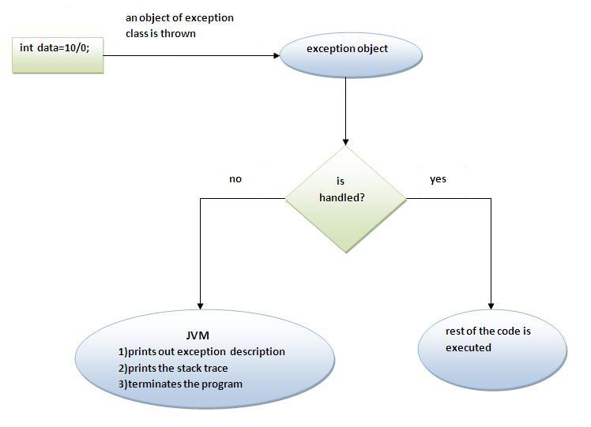

The JVM firstly checks whether the exception is handled or not. If exception is not handled, JVM provides a default exception handler that performs the following tasks:

* Prints out exception description.
* Prints the stack trace (Hierarchy of methods where the exception occurred).
* Causes the program to terminate.

But if exception is handled by the application programmer, normal flow of the application is maintained i.e. rest of the code is executed.

# Java catch multiple exceptions

## Java Multi catch block

If you have to perform different tasks at the occurrence of different Exceptions, use java multi catch block.

simple example of java multi-catch block.

**public** **class** MultipleCatchBlock

{

**public** **static** **void** main(String args[])

{

**try**

{

**int** a[]=**new** **int**[5];

     a[5]=30/0;

    }

**catch**(ArithmeticException e)

{

System.out.println("AE is completed");

}

**catch**(ArrayIndexOutOfBoundsException e)

{

System.out.println("AUOBE is completed");

}

**catch**(Exception e)

{

System.out.println("E is completed");

}

    System.out.println("hello welcome");

  }

}

**Output**: AE is completed

Hello welcome

#### Rule: At a time only one Exception is occured and at a time only one catch block is executed.

#### Rule: All catch blocks must be ordered from most specific to most general i.e. catch for ArithmeticException must come before catch for Exception .

**Example 2**

**class** MultipleCatchBlock1

{

**public** **static** **void** main(String args[])

{

**Try**

{

**int** a[]=**new** **int**[5];

     a[5]=30/0;

    }

**catch**(Exception e)

{

System.out.println("E is  completed");

}

**catch**(ArithmeticException e)

{

System.out.println("AE is completed");

}

**catch**(ArrayIndexOutOfBoundsException e)

{

System.out.println("AIUBE completed");

}

    System.out.println("hello welcome");

  }

}

Output:

Compile-time error

Java Nested try block

The try block within a try block is known as nested try block in java.

Why use nested try block

Sometimes a situation may arise where a part of a block may cause one error and the entire block itself may cause another error. In such cases, exception handlers have to be nested.

Syntax:

....

**try**

{

    statement 1;

    statement 2;

**try**

    {

        statement 1;

        statement 2;

    }

**catch**(Exception e)

    {

    }

}

**catch**(Exception e)

{

}

....

Java nested try example

simple example of java nested try block.

**class nestedtry**

**{**

**public static void main(String args[])**

**{**

**try**

**{**

**System.out.println("going to divide");**

**int b =39/0;**

**}**

**catch(ArithmeticException e)**

**{**

**System.out.println(e);**

**}**

**try**

**{**

**int a[]=new int[5];**

**a[5]=4;**

**}**

**catch(ArrayIndexOutOfBoundsException e)**

**{**

**System.out.println(e);**

**}**

**catch(Exception e)**

**{**

**System.out.println("handeled");**

**}**

**System.out.println("normal flow..");**

**}**

**}**

Java finally block

**Java finally block** is a block that is used to execute important code such as closing connection, stream etc.

Java finally block is always executed whether exception is handled or not.

Java finally block must be followed by try or catch block.

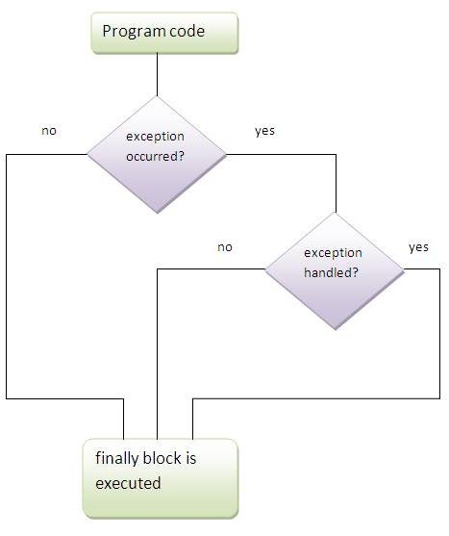

#### Note: If you don't handle exception, before terminating the program, JVM executes finally block(if any).

## Why use java finally

* Finally block in java can be used to put "cleanup" code such as closing a file, closing connection etc.

## Usage of Java finally

### Case 1

finally example where **exception doesn't occur**.

### Case 2

finally example where **exception occurs and not handled**.

### Case 3

finally example where **exception occurs and handled**.

**class FinallyBlock**

**{**

**public static void main(String args[])**

**{**

**try**

**{**

**int data=25/0;**

**System.out.println(data);**

**}**

**catch(ArithmeticException e)**

**{**

**System.out.println(e);**

**}**

**finally**

**{**

**System.out.println("finally block is always executed");**

**}**

**System.out.println("hello welcome");**

**}**

**}**

#### Rule: For each try block there can be zero or more catch blocks, but only one finally block.

#### Note: The finally block will not be executed if program exits(either by calling System.exit() or by causing a fatal error that causes the process to abort).

Java throw keyword

The Java throw keyword is used to explicitly throw an exception.

We can throw either checked or uncheked exception in java by throw keyword. The throw keyword is mainly used to throw custom exception.

**Syntax of java throw keyword**

**throw** exception;

example of throw IOException.

**throw** **new** IOException("sorry device error”);

java throw keyword example

we have created the validate method that takes integer value as a parameter. If the age is less than 18, we are throwing the ArithmeticException otherwise print a message welcome to vote.

**public** **class** TestThrow1{

**static** **void** validate(**int** age){

**if**(age<18)

**throw** **new** ArithmeticException("not valid");

**else**

      System.out.println("welcome to vote");

   }

**public** **static** **void** main(String args[]){

      validate(13);

      System.out.println("rest of the code...");

  }

}

[**Test it Now**](http://www.javatpoint.com/opr/test.jsp?filename=TestThrow1)

Output:

Exception in thread main java.lang.ArithmeticException:not valid

# Java Exception propagation

|  |
| --- |
| An exception is first thrown from the top of the stack and if it is not caught, it drops down the call stack to the previous method,If not caught there, the exception again drops down to the previous method, and so on until they are caught or until they reach the very bottom of the call stack.This is called exception propagation. |

#### Rule: By default Unchecked Exceptions are forwarded in calling chain (propagated).

***Program of Exception Propagation***

**class** TestExceptionPropagation1{

**void** m(){

**int** data=50/0;

  }

**void** n(){

    m();

  }

**void** p(){

**try**{

    n();

   }**catch**(Exception e){System.out.println("exception handled");}

  }

**public** **static** **void** main(String args[]){

   TestExceptionPropagation1 obj=**new** TestExceptionPropagation1();

   obj.p();

   System.out.println("normal flow...");

  }

}

Output:exception handled

normal flow...

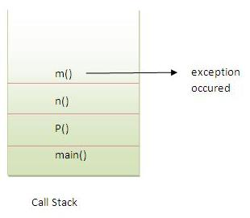

In the above example exception occurs in m() method where it is not handled,so it is propagated to previous n() method where it is not handled, again it is propagated to p() method where exception is handled.

Exception can be handled in any method in call stack either in main() method,p() method,n() method or m() method.

#### Rule: By default, Checked Exceptions are not forwarded in calling chain (propagated).

***Program which describes that checked exceptions are not propagated***

**class** TestExceptionPropagation2{

**void** m(){

**throw** **new** java.io.IOException("device error");//checked exception

  }

**void** n(){

    m();

  }

**void** p(){

**try**{

    n();

   }**catch**(Exception e){System.out.println("exception handeled");}

  }

**public** **static** **void** main(String args[]){

   TestExceptionPropagation2 obj=**new** TestExceptionPropagation2();

   obj.p();

   System.out.println("normal flow");

  }

}

Output:Compile Time Error

Java throws keyword

The **Java throws keyword** is used to declare an exception. It gives an information to the programmer that there may occur an exception so it is better for the programmer to provide the exception handling code so that normal flow can be maintained.

Exception Handling is mainly used to handle the checked exceptions. If there occurs any unchecked exception such as NullPointerException, it is programmers fault that he is not performing check up before the code being used.

Syntax of java throws

return\_type method\_name() **throws** exception\_class\_name{

//method code

}

Advantage of Java throws keyword

Now Checked Exception can be propagated (forwarded in call stack).

It provides information to the caller of the method about the exception.

Java throws example

Let's see the example of java throws clause which describes that checked exceptions can be propagated by throws keyword.

**import** java.io.IOException;

**class** Testthrows1{

**void** m()**throws** IOException{

**throw** **new** IOException("device error");//checked exception

  }

**void** n()**throws** IOException{

    m();

  }

**void** p(){

**try**{

    n();

   }**catch**(Exception e){System.out.println("exception handled");}

  }

**public** **static** **void** main(String args[]){

   Testthrows1 obj=**new** Testthrows1();

   obj.p();

   System.out.println("normal flow...");

  }

}

[**Test it Now**](http://www.javatpoint.com/opr/test.jsp?filename=Testthrows1)

Output:

exception handled

normal flow...

***Rule: If you are calling a method that declares an exception, you must either caught or declare the exception.***

|  |
| --- |
| There are two cases:   1. **Case1:**You caught the exception i.e. handle the exception using try/catch. 2. **Case2:**You declare the exception i.e. specifying throws with the method. |

Case1: You handle the exception

* In case you handle the exception, the code will be executed fine whether exception occurs during the program or not.

**import** java.io.\*;

**class** M{

**void** method()**throws** IOException{

**throw** **new** IOException("device error");

 }

}

**public** **class** Testthrows2{

**public** **static** **void** main(String args[]){

**try**{

     M m=**new** M();

     m.method();

    }**catch**(Exception e){System.out.println("exception handled");}

    System.out.println("normal flow...");

  }

}

[**Test it Now**](http://www.javatpoint.com/opr/test.jsp?filename=Testthrows2)

Output:exception handled

normal flow...

Case2: You declare the exception

* A)In case you declare the exception, if exception does not occur, the code will be executed fine.
* B)In case you declare the exception if exception occures, an exception will be thrown at runtime because throws does not handle the exception.

***A)Program if exception does not occur***

**import** java.io.\*;

**class** M{

**void** method()**throws** IOException{

  System.out.println("device operation performed");

 }

}

**class** Testthrows3{

**public** **static** **void** main(String args[])**throws** IOException{//declare exception

     M m=**new** M();

     m.method();

    System.out.println("normal flow...");

  }

}

[**Test it Now**](http://www.javatpoint.com/opr/test.jsp?filename=Testthrows3)

Output:device operation performed

normal flow...

***B)Program if exception occurs***

**import** java.io.\*;

**class** M{

**void** method()**throws** IOException{

**throw** **new** IOException("device error");

 }

}

**class** Testthrows4{

**public** **static** **void** main(String args[])**throws** IOException{//declare exception

     M m=**new** M();

     m.method();

    System.out.println("normal flow...");

  }

}

[**Test it Now**](http://www.javatpoint.com/opr/test.jsp?filename=Testthrows4)

Output:Runtime Exception

Difference between throw and throws in Java

There are many differences between throw and throws keywords. A list of differences between throw and throws are given below:

|  |  |  |
| --- | --- | --- |
| No. | throw | Throws |
| 1) | Java throw keyword is used to explicitly throw an exception. | Java throws keyword is used to declare an exception. |
| 2) | Checked exception cannot be propagated using throw only. | Checked exception can be propagated with throws. |
| 3) | Throw is followed by an instance. | Throws is followed by class. |
| 4) | Throw is used within the method. | Throws is used with the method signature. |
| 5) | You cannot throw multiple exceptions. | You can declare multiple exceptions e.g. public void method()throws IOException,SQLException. |

Java throw example

**void** m(){

**throw** **new** ArithmeticException("sorry");

}

Java throws example

**void** m()**throws** ArithmeticException{

//method code

}

Java throw and throws example

**void** m()**throws** ArithmeticException{

**throw** **new** ArithmeticException("sorry");

}

Difference between final, finally and finalize

There are many differences between final, finally and finalize. A list of differences between final, finally and finalize are given below:

|  |  |  |  |
| --- | --- | --- | --- |
| **No.** | **final** | **Finally** | **finalize** |
| 1) | Final is used to apply restrictions on class, method and variable. Final class can't be inherited, final method can't be overridden and final variable value can't be changed. | Finally is used to place important code, it will be executed whether exception is handled or not. | Finalize is used to perform clean up processing just before object is garbage collected. |
| 2) | Final is a keyword. | Finally is a block. | Finalize is a method. |

Java final example

**class** FinalExample{

**public** **static** **void** main(String[] args){

**final** **int** x=100;

x=200;//Compile Time Error

}}

Java finally example

**class** FinallyExample{

**public** **static** **void** main(String[] args){

**try**{

**int** x=300;

}**catch**(Exception e){System.out.println(e);}

**finally**{System.out.println("finally block is executed");}

}}

Java finalize example

**class** FinalizeExample{

**public** **void** finalize(){System.out.println("finalize called");}

**public** **static** **void** main(String[] args){

FinalizeExample f1=**new** FinalizeExample();

FinalizeExample f2=**new** FinalizeExample();

f1=**null**;

f2=**null**;

System.gc();

}}

# ExceptionHandling with MethodOverriding in Java

|  |
| --- |
| There are many rules if we talk about methodoverriding with exception handling. The Rules are as follows:   * **If the superclass method does not declare an exception**   + If the superclass method does not declare an exception, subclass overridden method cannot declare the checked exception but it can declare unchecked exception. * **If the superclass method declares an exception**   + If the superclass method declares an exception, subclass overridden method can declare same, subclass exception or no exception but cannot declare parent exception. |

### If the superclass method does not declare an exception

#### 1) Rule: If the superclass method does not declare an exception, subclass overridden method cannot declare the checked exception.

**import** java.io.\*;

**class** Parent{

**void** msg(){System.out.println("parent");}

}

**class** TestExceptionChild **extends** Parent{

**void** msg()**throws** IOException{

    System.out.println("TestExceptionChild");

  }

**public** **static** **void** main(String args[]){

   Parent p=**new** TestExceptionChild();

   p.msg();

  }

}

Output:Compile Time Error

#### 2) Rule: If the superclass method does not declare an exception, subclass overridden method cannot declare the checked exception but can declare unchecked exception.

**import** java.io.\*;

**class** Parent{

**void** msg(){System.out.println("parent");}

}

**class** TestExceptionChild1 **extends** Parent{

**void** msg()**throws** ArithmeticException{

    System.out.println("child");

  }

**public** **static** **void** main(String args[]){

   Parent p=**new** TestExceptionChild1();

   p.msg();

  }

}

Output:child

### If the superclass method declares an exception

#### 1) Rule: If the superclass method declares an exception, subclass overridden method can declare same, subclass exception or no exception but cannot declare parent exception.

### Example in case subclass overridden method declares parent exception

**import** java.io.\*;

**class** Parent{

**void** msg()**throws** ArithmeticException{System.out.println("parent");}

}

**class** TestExceptionChild2 **extends** Parent{

**void** msg()**throws** Exception{System.out.println("child");}

**public** **static** **void** main(String args[]){

   Parent p=**new** TestExceptionChild2();

**try**{

   p.msg();

   }**catch**(Exception e){}

  }

}

Output:Compile Time Error

### Example in case subclass overridden method declares same exception

**import** java.io.\*;

**class** Parent{

**void** msg()**throws** Exception{System.out.println("parent");}

}

**class** TestExceptionChild3 **extends** Parent{

**void** msg()**throws** Exception{System.out.println("child");}

**public** **static** **void** main(String args[]){

   Parent p=**new** TestExceptionChild3();

**try**{

   p.msg();

   }**catch**(Exception e){}

  }

}

Output:child

### Example in case subclass overridden method declares subclass exception

**import** java.io.\*;

**class** Parent{

**void** msg()**throws** Exception{System.out.println("parent");}

}

**class** TestExceptionChild4 **extends** Parent{

**void** msg()**throws** ArithmeticException{System.out.println("child");}

**public** **static** **void** main(String args[]){

   Parent p=**new** TestExceptionChild4();

**try**{

   p.msg();

   }**catch**(Exception e){}

  }

}

Output:child

### Example in case subclass overridden method declares no exception

**import** java.io.\*;

**class** Parent{

**void** msg()**throws** Exception{System.out.println("parent");}

}

**class** TestExceptionChild5 **extends** Parent{

**void** msg(){System.out.println("child");}

**public** **static** **void** main(String args[]){

   Parent p=**new** TestExceptionChild5();

**try**{

   p.msg();

   }**catch**(Exception e){}

  }

}

Output:child

Java Custom Exception

If you are creating your own Exception that is known as custom exception or user-defined exception. Java custom exceptions are used to customize the exception according to user need.

By the help of custom exception, you can have your own exception and message.

simple example of java custom exception.

**class InvalidAgeException extends Exception**

**{**

**InvalidAgeException(String s)**

**{**

**super(s);**

**}**

**}**

**class CustomException**

**{**

**static void validate(int age)throws InvalidAgeException**

**{**

**if(age<18)**

**throw new InvalidAgeException("not valid");**

**else**

**System.out.println("welcome to vote");**

**}**

**public static void main(String args[])**

**{**

**try**

**{**

**validate(23);**

**}**

**catch(Exception m)**

**{**

**System.out.println("Exception occured: "+m);**

**}**

**System.out.println("hello all the best");**

**}**

**}** [Test it Now](http://www.javatpoint.com/opr/test.jsp?filename=TestCustomException1" \t "_blank)

Output:Exception occured: InvalidAgeException:not valid

Hello all the best